Flow Physics of Diffused-Exit Film Cooling Holes Fed by an Internal Crossflow
Proposal for Ph.D. Dissertation

John W. McClintic

February 2016

Table of Contents

- Introduction 2
  - Gas Turbine Engines 2
  - Film Cooling Analysis 3
  - Flow Physics of Film Cooling 7
    - Injection from Cylindrical Film Cooling Holes 7
    - Injection from Diffused Film Cooling Holes 13
    - Effect of Internal Coolant Feed 17
    - Relevance of Proposed Study 21
- Experimental Facility 22
  - Current Facility 22
  - Film Cooling Models 24
  - Overview of Measurement Techniques 24
  - Development of New Facility 26
- Dissertation Objectives 27
- Schedule 30
- Nomenclature 30
- References 31

Section 1: Introduction
1.1 Gas Turbine Engines
Gas turbine engines are highly valuable to modern society, serving important roles in jet propulsion, electricity generation, and marine power plants. These engines offer the advantage of producing a large amount of power relative to their size and weight, which is important for a number of applications, especially for jet propulsion. Because the usage of these engines is so prevalent, any improvement in the fuel efficiency of gas turbine engines can lead to important competitive advantages for engine manufacturers and significant benefits for entire industries. For example, according the U.S. Energy Information Administration’s (EIA) 2014 annual review [1] the United States alone consumed almost 540 million barrels of jet fuel in 2014, producing an energy equivalent of about 3 quads (quadrillion BTU) for the fuel cost of 62.4 billion dollars. Just a 1% increase in fuel efficiency or aircraft engines would save the transportation industry over half a billion dollars. Even larger benefits are available from small increases in the efficiency of land based power generation turbines, especially as the U.S. starts to use more and more natural gas for power generation relative to other fossil fuels.
The gas turbine engine, diagrammed in Figure 1.1, consists of three main stages, or components. In the first stage, air is pressurized as it passes through a compressor. In the second stage, fuel is injected and burned in the combustor, heating the air-fuel product mixture. Finally, this high pressure, hot gas is expanded through the turbine which converts the flow energy into rotational energy, which can be used to power the compressor and/or produce electrical power. In the case of jet engines, the high energy gasses are then ejected through a nozzle to produce thrust.
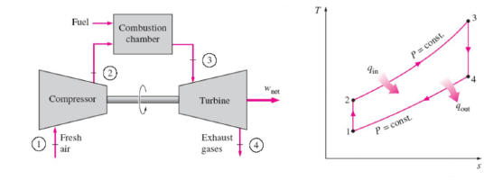
Figure 1.1: Diagram of an ideal Brayton cycle [2]
A thermodynamic analysis can be used to determine the thermal efficiency of the gas turbine engine by modeling it as a Brayton cycle, diagrammed in Figure 1.1. Thermal efficiency of a Brayton cycle is the ratio of the net work produced by the cycle to the net heat input to the cycle shown by Eqn. 1.1 below. To derive the final form of the equation, a constant specific heat was assumed.
$$η_{th}=\frac{{\dot{W}}_{net}}{{\dot{Q}}_{in}}=1-\frac{T_{4}-T_{1}}{T_{3}-T_{2}}$$ | (1.1)

Given that for most practical applications, the engine inlet and outlet temperatures, T₁ and T₂ respectively, are set by the environment, the thermal efficiency of the engine is primarily driven by the combustion outlet or turbine inlet temperature, T₃, with higher turbine inlet temperatures yielding higher cycle efficiencies. Therefore, modern gas turbine engines are built to operate at increasingly high turbine inlet temperatures. Modern jet engines will often have turbine inlet temperatures in excess of 2000 K [3], which is much hotter than the allowable metal temperature for the combustion chamber and the first turbine stages.
The high temperatures imposed on the hot gas path components of a gas turbine engine by the need for greater overall cycle efficiency has necessitated the development of both new materials to better withstand these high temperatures and active cooling schemes to deliver cooling air to the affected parts. To provide cool air to the hot gas path components, air is pulled from the high pressure compressor and supplied to the various hot gas path components via channels underneath the exposed surfaces. Complex internal geometries, such as ribbed channels or internal impingement cooling are often implemented to increase heat transfer from the coolant to the metal part. For high heat load parts, such as first stage rotor blades and stator guide vanes, the coolant is often injected through discrete holes in the surface of the part into the flow around the surface of the airfoil in order to form a thin layer of cool air between the hot mainstream gas and the metal surface. This process is called film cooling. Figure 1.2 shows a typical cooling configuration for a first stage turbine blade where air is fed into the base of the blade and through internal channels, and is then injected onto the external surface of the blade through discrete holes.
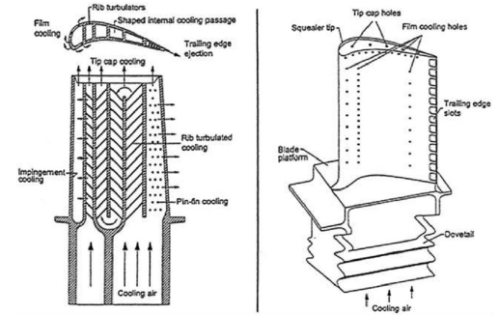
Figure 1.2: Diagram of an early-stage turbine blade featuring internal and external cooling [4]
1.2 Film Cooling Analysis
Film cooling in gas turbine engines is the process by which relatively cool air is injected through discrete holes into the overflowing hot mainstream gas in order to form a protective layer of cold air between the surface of the part and the hot gas. The interaction between the mainstream and the cold jet is a complicated process and is dependent on a number of flow and geometric parameters. The most commonly studied flow parameters are those characterizing the coolant injection rate: the coolant to mainstream velocity ratio, blowing ratio, and momentum flux ratio defined in Equations 1.2, 1.3, and 1.4 respectively. Blowing ratio and momentum flux ratios include the density ratio between the injected coolant and the overflowing mainstream, defined by Equation 1.5. Typical engine density ratios are typically in the range of DR = 1.8-2.2.
$$VR≡\frac{U_{c}}{U_{∞}}$$ | (1.2)
$$M≡\frac{ρ_{c}U_{c}}{ρ_{∞}U_{∞}}$$ | (1.3)
$$I≡\frac{ρ_{c}U_{c}^{2}}{ρ_{∞}U_{∞}^{2}}$$ | (1.4)
$$DR≡\frac{ρ_{c}}{ρ_{∞}}$$ | (1.5)

Other flow parameters of importance are the external and internal Reynolds numbers, defined in Equations 1.6 and 1.7 respectively. Note that the external Reynolds number is defined by the mainstream parameters using the cooling hole diameter as the characteristic length, while the internal Reynolds number scales with the geometry of the internal channel. Also of importance are the approach mainstream turbulence intensity Tu, and integral length scale, Λ_{x} as well as the approach boundary layer characteristics.
$$Re_{d}≡\frac{ρ_{∞}U_{∞}d}{μ_{∞}}$$ | (1.6)
$$Re_{ch}≡\frac{ρ_{ch}U_{ch}d_{H,ch}}{μ_{ch}}$$ | (1.7)

The effect of coolant injection rate is demonstrated by thermal profiles of film cooling jets, shown in Figure 1.3. The temperatures in these plots are normalized as follows:
$$θ=\frac{T_{∞}-T}{T_{∞}-T_{c}}$$ | (1.8)

As the jet is injected, the overflowing mainstream forces it down onto the surface of the part. This jet-mainstream interaction requires a significant level of mixing between the coolant and the mainstream gas such that the temperature of the jet decays considerably going downstream. As coolant is injected at higher and higher velocities, it goes from being attached to the wall as shown in Figure 1.3a to where the core of the jet is fully detached from the wall as shown in Figure 1.3c. This occurs because a higher velocity jet is more difficult for the overflowing mainstream gas to turn such that the coolant remains close to the wall for maximum cooling benefit. Obviously, a fully detached film cooling jet is undesirable for protecting the part from the hot mainstream gas.
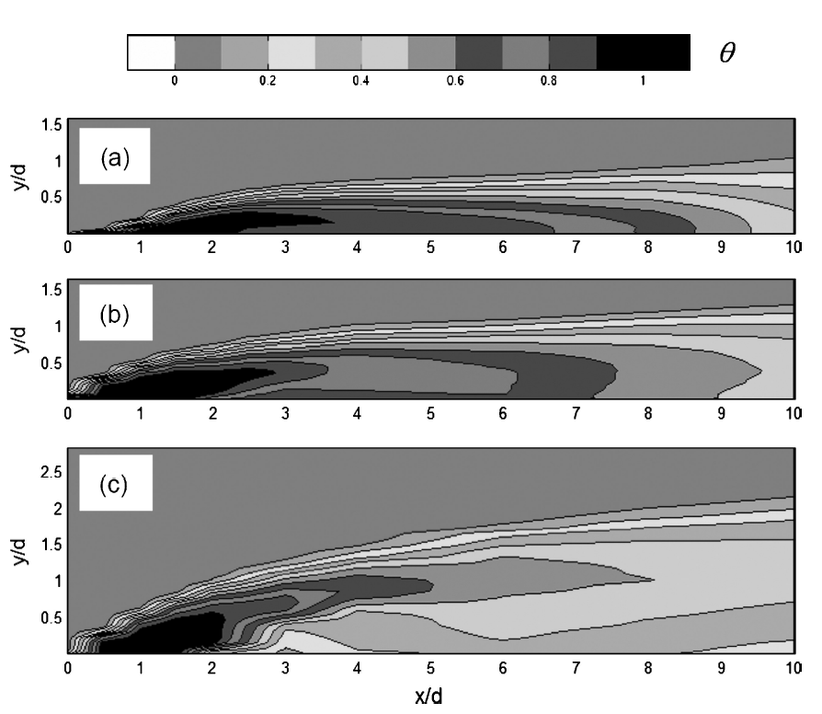
Figure 1.3: A profile of a film cooling jet showing the decay of the normalized temperature downstream of the hole for an attached jet (a), a partially detached jet (b), and a fully detached jet (c) [5]
Ultimately, the effectiveness of any cooling scheme is determined by the temperature of the exposed metal surface. The parameter used to quantify this is the overall cooling effectiveness, defined as follows:
$$φ≡\frac{T_{∞}-T_{m}}{T_{∞}-T_{c}}$$ | (1.9)

While this is ultimately the parameter used to holistically evaluate the combined internal and external cooling scheme along with any additional protective effects provided by ceramic coatings, it is often desirable to evaluate the effectiveness of the internal and external cooling schemes individually. In order to understand the external performance of a given film cooling configuration, two parameters are needed: adiabatic effectiveness, η, and heat transfer augmentation, HTA. Adiabatic, or film cooling effectiveness is the normalized adiabatic wall temperature of a film cooled surface and is generally considered the driving temperature for heat transfer into a film cooled surface. It is defined as follows:

$$η≡\frac{T_{∞}-T_{aw}}{T_{∞}-T_{c,e}}$$ | (1.10)

It is also important to understand how injection of film cooling affects the heat transfer coefficient between the overflowing gas and the film-cooled part. Film cooling disturbs the upstream boundary layer and can result in increased turbulence and heat transfer rate into the film-cooled part. It is therefore important to take this increase in heat transfer, or heat transfer augmentation into account:
$$HTA=\frac{h_{f}}{h_{0}}$$ | (1.11)

Both adiabatic effectiveness and heat transfer augmentation are important for gas turbine airfoil designers. In order to make use of computational tools such as finite element heat transfer solvers, it is necessary to have the correct boundary conditions. Adiabatic effectiveness and heat transfer augmentation provide the necessary external boundary conditions, provided that the designer can predict the heat transfer coefficient without film cooling, h₀. With knowledge of the internal channel heat transfer coefficient and the coolant temperature, the designer should have all that is needed to predict the overall effectiveness of any cooling scheme, φ.
To demonstrate the relationship between the internal and external heat transfer effects, a one-dimensional analysis can be performed, assuming heat transfer through a wall of thickness t and thermal conductivity k with uniform external and internal heat transfer coefficients and temperatures. The heat transfer through the wall is calculated as follows:
$$q_{f}"=h_{f}(T_{aw}-T_{m})=\frac{T_{m}-T_{c}}{t/k-1/{h_{i}}}$$ | (1.12)

By normalizing and solving for the overall effectiveness, it can be shown that:
$$φ=\frac{1-χη}{1+Bi+{h_{f}}/{h_{i}}}+χη$$ | (1.13)
where:
$$χ=\frac{T_{∞}-T_{c,e}}{T_{∞}-T_{c}}$$ | (1.14)

$$Bi=\frac{h_{f}t}{k}$$ | (1.15)

The coolant warming factor, χ, accounts for the difference in the coolant temperature used to normalize adiabatic and overall effectiveness. Adiabatic effectiveness is typically normalized using the coolant hole exit temperature in order to isolate the external effects of coolant spreading over the cooled surface from any warming of the coolant through the coolant feed system. Overall effectiveness, on the other hand, takes into account all cooling of the part and therefore is typically normalized by the coolant temperature at the inlet of the part. Equation 1.13 demonstrates the important parameters that must be considered for evaluating any film cooling configuration. Given that the denominator of the first part of Eqn. 1.13 is greater than unity, an increase in adiabatic effectiveness results in an increase in overall effectiveness up to the point where η = φ = 1. Conversely, an increase in h_{f}, will result in decreasing overall effectiveness, as the heat transfer coefficient between the warmer overflowing gas increases, while an increase in h_{i} will result in increased overall effectiveness due to improved internal cooling. It is important to note, however, that these three parameters rarely change independently. For example, a multitude of studies have shown that changing the internal coolant feed can change both adiabatic effectiveness and heat transfer augmentation. It is possible, for certain cooling hole configurations, that increasing the internal coolant Reynolds number will cause an increase in internal heat transfer while reducing the adiabatic effectiveness and increasing the external heat transfer augmentation. These competing effects must be taken into account by engine designers when determining how hot gas path components are cooled.
1.3 Flow Physics of Film Cooling
A considerable amount of research has been done to understand the effects of internal and external cooling individually, but only a few studies have attempted to examine how the external cooling is affected by the internal coolant feed, and even fewer have attempted to measure the complex flow and thermal fields that show the physical mechanisms that govern how internal flow affects external cooling. It is important to understand the flow physics of film cooling in order to make sense of how the internal feed affects external film cooling.
1.3.1 Injection from Cylindrical Film Cooling Holes
The vast majority of film cooling studies in the open literature have studied cylindrical film cooling holes of constant circular cross-sectional area. These holes are characterized by a relatively poor performance compared to other hole geometries and jet lift-off at low blowing ratios. As seen in Figure 1.4, as the rate of cooling injection increases, the coverage of the film cooling jet increases with increasing injection rate up to a blowing ratio of M = 0.6, after which, the core of the jet detaches from the wall until only a slight trace of the coolant can be observed on the surface. The jet detachment can be observed in the narrowing of the jet trace on the film-cooled surface. This detachment of the jet core does not necessarily force a low effectiveness further downstream because the coolant will typically disperse down towards the wall as the jet propagates downstream. While the data shown in Figure 1.4 is typical of cylindrical cooling holes, the peak effectiveness levels and optimum blowing ratio are dependent on a vast number of parameters that cannot be fully discussed here. For a more complete discussion of the various parameters that affect gas turbine film cooling, please refer to Bogard and Thole [5].
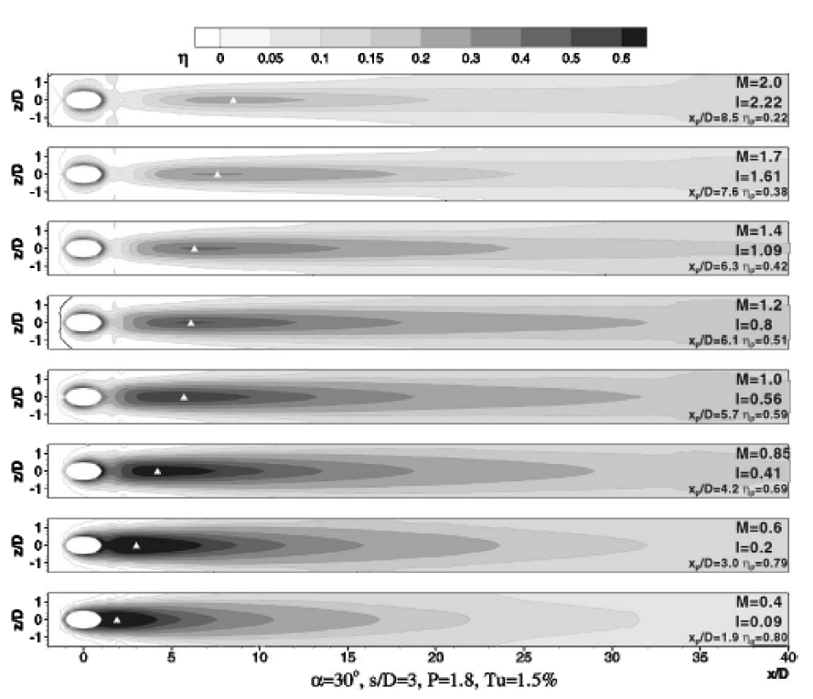
Figure 1.4 Adiabatic effectiveness of cylindrical film cooling holes with increasing injection rates [6]
Heat transfer augmentation downstream of a row of round film cooling holes is shown conceptually in Figure 1.5. Typically, values of heat transfer augmentation downstream of round, axially injected film cooling holes (γ = 0) are between h_{f}/h₀ = 1.0 and 1.3, although higher values have been measured near the holes and for higher blowing ratios. Often the highest values of heat transfer augmentation occur in the centerline downstream of the hole where the coolant jet is forced down by the mainstream onto the surface. Higher heat transfer augmentation at higher blowing ratios is primarily an effect of increased turbulent mixing and mainstream blockage. These effects are better understood after considering the primary flow structures of jets issuing from round film cooling holes.
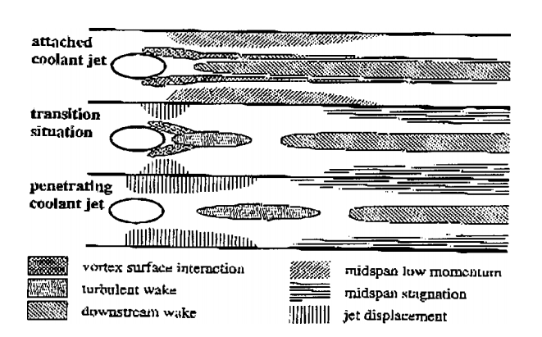
Figure 1.5: Locations and sources of elevated heat transfer downstream of cylindrical film cooling holes [7]
The film cooling problem is an extension of the classical fluid mechanics problem of a jet injecting into crossflow, and has received considerable attention from numerical and computational studies alike. Earlier studies, such as Foss [8], Crabb et al [9], and Andreopoulos and Rodi [10], experimentally studied the flow field of jets that were fed by a long tube and normally injected into an overflowing mainstream gas. Andreopoulos and Rodi used three-component hotwire anemometry to measure flow fields around a scaled-up normally injected film cooling hole at varying coolant injection velocity ratio. Figure 1.6 conceptually shows the jet-mainstream interaction they experimentally observed. The upstream boundary layer rolls up at the leading edge of the film cooling hole, causing a region of reversed flow that wraps around the issuing jet in a horseshoe vortex similar to that which would be seen around a solid cylinder protruding from the wall. The mainstream flow accelerates around and above the issuing jet, resulting in strong shear layers between the jet and high levels of turbulence intensity. For low injection rates, the mainstream flow deflects the streamlines inside the hole in the downstream direction, causing the hole exit velocity profile to be skewed. At higher injection flow rates, the coolant is ejected further into the mainstream, resulting in increased mainstream blockage by the jet and increased turbulence generation. Flow further downstream of the jet is characterized by a wake region that is larger for higher injection rates and a counter-rotating vortex pair (CRVP) within the jet itself. These vortices have been observed by a considerable number of studies and are considered to be one of the most important flow features to jets issuing from cylindrical film cooling holes. These vortices draw mainstream fluid from the sides of the jet up into the center of the jet, resulting in a kidney-shaped jet profile. They also encourage jet lift-off through the vertical force they exert on each other, bringing coolant away from the wall.
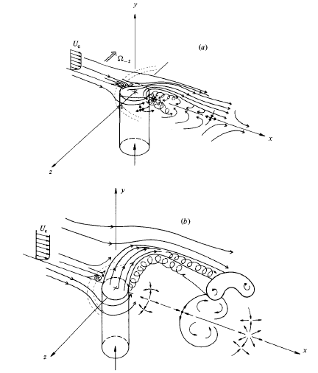
Figure 1.6 Flow field features for a round film cooling jet with (a) VR = 0.5 and (b) VR = 2.0 [10]
The majority of film-cooled hot gas components have short film cooling holes, as opposed to the long tubes featured in early studies where the flow would exit with a fully developed velocity profile. The work of Pietzryk et al [11, 12] was the first study to measure flow fields of film cooling jets emanating from short (L/d = 3.5) inclined (α = 35°) cylindrical cooling holes. The cooling holes were fed by a quiescent plenum, which is a common method of feeding film cooling holes for academic studies in order to allow for consistency from study to study. Unlike holes fed by a long tube, the velocity profile at the exit of the hole was skewed and varied with coolant-to-mainstream velocity ratio. For low velocity ratio, VR = 0.5, it was found that coolant primarily exited from the downstream portion of the cooling hole, while for higher velocity ratio, VR = 1.0, the coolant primarily exited from the upstream portion of the cooling hole. The difference between these two velocity ratios suggested competing effects due to the mainstream and hole inlet. The overflowing mainstream acts to block the coolant from exiting from the upstream portion of the hole, an effect that dominates at lower blowing ratios where the injected cooling jet has low momentum relative to the mainstream. Counteracting the mainstream blockage effect is the hole entrance effect that causes a separation region to form on the downstream edge of the hole inlet (relative to the overflowing mainstream) because the incoming flow into the hole must navigate a sharp turn to enter the hole. This separation region forces the majority of the coolant to accelerate around it, leading to jetting of the coolant and biasing the outlet velocity towards the upstream side of the cooling hole outlet.
This separation and jetting effect from the hole inlet was also predicted by a computational study performed by Leylek and Zerkle [13] that replicated the same geometry used by Pietzryk et al [11] and can be seen in Figure 1.7. They also predicted a counter-rotating vortex pair within the film cooling hole centered within the recirculation region as a result of the hole entrance effect. Like experimental studies before them, they found considerable turbulence generation within the hole at higher injection flow rates in addition to high turbulence generation in the shear layer between the mainstream and the cooling jet. However, this study (like many other computational studies) failed to predict the adiabatic effectiveness on the surface due to under-prediction of jet lateral spreading.
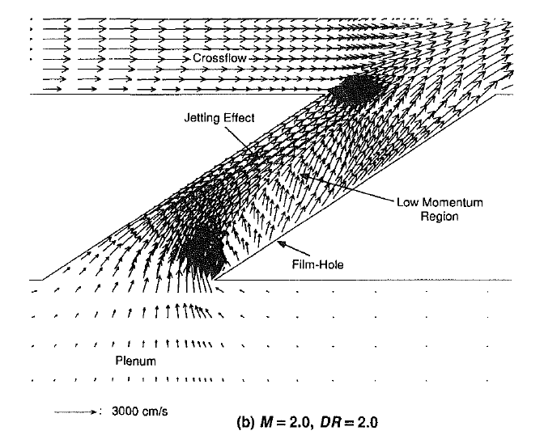
Figure 1.7: Computational prediction of flow through a short cylindrical film cooling hole fed by a quiescent plenum [13]
Another study by Cho and Goldstein [14] measured heat transfer inside normally injected short film cooling holes by means of naphthalene sublimation and the mass transfer analogy. They observed that within the hole there were four distinct regions: the separation region characterized by low heat transfer rate, the size of which increases with increasing injection rate, the reattachment region characterized by high heat transfer and the separated flow reattaching to the wall, the developing region characterized by the development of a boundary layer along the wall, and a region affected by the overflowing mainstream where the coolant was pushed toward the downstream edge of the hole. They found that the overall Nusselt number in the hole scaled with hole Reynolds number.
It is also important to consider thermal fields when studying the physics of film cooling flow fields because while velocity and turbulence measurements may reveal valuable information about flow structures, thermal fields are useful in showing how the coolant disperses above the film cooled surface. Thole et al [15] performed thermal field measurements downstream of cylindrical holes fed by a plenum in order to investigate film cooling jet detachment. It was found that jet detachment primarily scaled with the momentum flux ratio, as opposed to blowing ratio or coolant-to-mainstream velocity ratio. Kohli and Bogard [16] made mean flow and thermal field measurements. Thermal field measurements showed the coolant warming considerably within the first few diameters downstream of the cooling hole. Another pair of studies by Kohli and Bogard [17, 18] measured time-resolved thermal fields using a cold wire probe. These studies observed very high fluctuating temperatures in the near hole region, especially on the top edge of the jet, indicating that the dispersion of coolant occurred primarily in the wall-normal direction. The time histories of temperature and probability density functions showed periodically fluctuating temperatures due to pockets of mainstream and coolant gasses moved through a given location. They also found that high mainstream turbulence intensity, Tu = 20%, greatly increased the rate of coolant dispersion and that high fluctuating temperatures moved down to the surface, as opposed to the low turbulence condition, Tu = 0.5%, where there was a distinct region of peak fluctuating temperature away from the wall. Another study by Kohli and Bogard [19] simultaneously measured velocity and thermal fields using two-component LDV in conjunction with a cold wire probe. It was found that the coolant mainstream interface, defined by the peak location of fluctuating temperature, coincided with the region of peak turbulent shear stress. They also showed that the peak turbulent shear stress was a factor of two greater than shear stress typically found in a thermal boundary layer. It was also shown that the assumption of a constant turbulent Prandtl number, commonly done in computational studies, is a poor assumption as this value was shown to vary by a factor of four. When high freestream turbulence was introduced, the whole flow field was dominated by the large scale turbulence of the mainstream, which transported the coolant far above the wall.
A number of flow visualization studies of film cooling from cylindrical holes have been performed, including those by Lee et al [20, 21, 22], Kelso et al [23], and Morton and Ibbetson [24]. These studies provided further insight on flow features such as the counter-rotating vortex pair [19, 23], wake vortices [23, 24], and the horseshoe vortex [23], and evaluated the effect of parameters such as injection angle [20, 22], compound angle [21], L/d [22], and jet Reynolds number [23]. Other studies of flow fields around cylindrical holes used particle image velocimetry (PIV) to provide simultaneous, higher resolution flow field data such as those performed by Bernsdorf et al [25], Jessen et al [26], and Wright et al [27]. These PIV studies provided further insight into aspects of the jet-mainstream shear layer and the counter-rotating vortex pair within the jet. A notable recent study of a plenum-fed cylindrical film cooling study was a time-resolved PIV study performed by Eberly and Thole [28] that investigated the effects of density ratio on film cooling. They observed that turbulence levels in the exiting jet scaled best with momentum flux ratio, I, but turbulence levels in the shear layer scaled better with blowing ratio, M. Their time-resolved measurements showed shear layer vortices forming with a spacing of approximately one hole diameter and had the appearance of Kelvin-Helmholtz style instabilities before a more fully turbulent shear layer developed further downstream.
Another notable recent study of flow within cylindrical film cooling holes was performed by Issakhanian et al [29] using magnetic resonance velocimetry to obtain a fully three dimensional time averaged flow fields over the full film cooling domain. They showed that a slight bias within the plenum feed led to an asymmetric swirling motion within the film cooling hole, rather than the symmetric CRVP predicted by Leylek and Zerkle [13]. They found that the intensity of this secondary flow within the hole scaled with increasing injection flow rate. Their measurements suggested that the strength and orientation of the in-hole vortices can either contribute to or detract from the strength of the primary CRVP formed within the jet as it propagates downstream.
1.3.2 Injection from Diffused Film Cooling Holes
The majority of film cooling research has been focused on the performance of discrete cylindrical film cooling holes, which was the standard film cooling geometry used in gas turbine engines for decades. Within the past couple decades, however, it has been conclusively shown that holes with diffused exits, commonly referred to as “shaped” film cooling holes, vastly outperform cylindrical holes in terms of film cooling effectiveness. As early as 1974, Goldstein et al [30] showed that diffused film cooling holes were less susceptible to cooling jet detachment than cylindrical holes. Therefore, shaped holes have largely replaced round holes in many modern gas turbine engines, although in places geometric limitations have necessitated the continued use of cylindrical holes [31]. Figure 1.8 shows two common types of shaped holes: the fan shaped hole (b) and the laidback fan shaped hole (a). The important geometric parameters of these holes are the lateral and forward diffusion angles (β and δ respectively) and the metering length (L_{T}), which is the length of the round cross-sectional part of the hole before it is diffused.
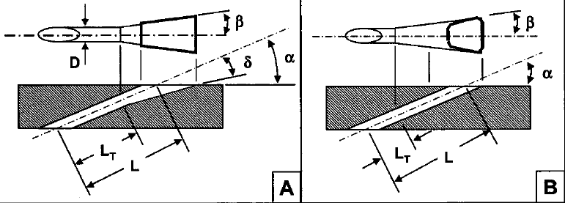
Figure 1.8: Diagram of commonly used diffused exit holes [31]
Given the greater number of variable parameters, there is a considerably larger range of shaped hole types and results throughout literature relative to round holes, making it difficult to compare results from one study to another. Figure 1.9 shows a sample of adiabatic effectiveness data from a row of shaped holes for increasing coolant injection rate. The shaped holes shown have lateral expansion angles of β = 7°, a forward expansion angle of δ = 7°, and a metering length of L_{T}/d = 2.5. The expansion angles for these holes are somewhat small relative to literature where some studies have used lateral expansion angles up to β = 18° and forward expansion angles of up to δ = 25°. It can be seen that for this geometry, the peak lateral spreading occurred at M = 1.0, higher than the peak lateral spreading for the cylindrical film cooling holes in Figure 1.4, and unlike cylindrical film cooling holes, the effectiveness did not severely drop off when coolant injection rate was increased, but stayed well attached due to the diffusion at the exit of the hole.
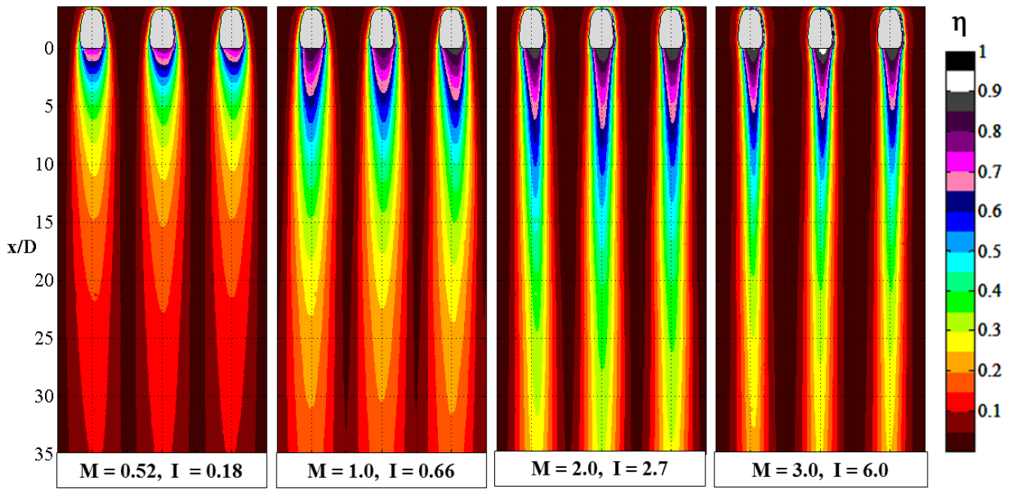
Figure 1.9: Adiabatic effectiveness for shaped film cooling holes with increasing coolant injection rate [32]
The heat transfer coefficient augmentation downstream of shaped holes has been shown to be highly dependent on the approach boundary layer characteristics as well as other parameters such as hole spacing and injection rate. Figure 1.10 shows typical values for h_{f}/h₀ for film cooling from shaped holes over a range of conditions. It is apparent that introducing film cooling from shaped holes has been shown to both reduce and increase heat transfer coefficients by up to a factor of two, depending on blowing ratio and the approach boundary layer thickness. Given the complexity of the flow fields for film cooling in general, a better understanding of the flow physics is required to better understand the performance of shaped film cooling holes.
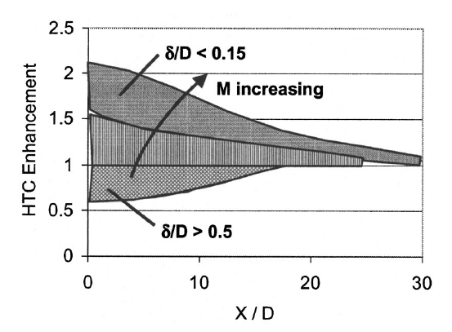
Figure 1.10: Heat transfer coefficient augmentation for film cooling from shaped holes [31]
A number of studies have undertaken to investigate the velocity and turbulence fields downstream of diffused exit film cooling holes. A study by Haven et al [33] used flow visualization in water to study different vortical structures in both fan-shaped and laidback fan-shaped holes fed by a coflowing plenum. They observed “anti-kidney vortices,” or a CRVP of opposite rotation to that observed in jets issuing from cylindrical holes, in the laidback fan-shaped holes that drew mainstream fluid into the top of the jet and pushed the coolant laterally outward over the surface, improving effectiveness. For the fan-shaped hole (no forward diffusion), they observed the formation of multiple anti-kidney and kidney vortices that mutually weakened each other, resulting in even better coolant coverage than the laidback fan-shaped holes. A study by Thole et al [34] made two-component LDV measurements for cylindrical, fan-shaped, and laidback fan-shaped film cooling holes fed by a co-flowing coolant supply. It was observed that flow from shaped holes had considerably reduced mainstream blockage at the upstream edge of the film cooling hole which reduced the acceleration of the mainstream around the hole and contributed to greatly reduced strength of the shear layers for the shaped hole jets relative to the cylindrical hole jets. Jet lift-off was also considerably reduced due to either the non-existence or severe weakening of the CRVP. The flow exiting the laidback fan-shaped hole primarily exited from the downstream edge of the diffuser due to the overflowing mainstream. For the laidback fan-shaped hole, evidence of mainstream ingestion was observed, which would result in decreased effectiveness for these holes as the hot mainstream air would warm the air exiting the hole. Another interesting result from this study was the difference in where turbulence was generated for round and shaped holes. For round holes, turbulence was primarily generated in the shear layer between the jet and the mainstream. On the other hand, because the shaped holes had large diffusion angles (β = 14°, δ = 15°), separation of the flow in the diffuser was the primary contributor to turbulence in the shaped holes. It should be noted that in both of the studies, [33 and 34] the film cooling holes were fed by something other than a quiescent plenum, which differs from the majority of the studies discussed so far. This difference in feed, for example, meant that there was no evidence of the separation region in the holes observed by Pietrzyk [11] in the measurements of Thole et al [34]. The effect of coolant feed configuration will be discussed in more detail in Section 1.3.3.
Around the same time a number of computational studies were performed to evaluate flow fields around shaped film cooling holes. Hyams and Leylek [35] studied a variety of hole shapes including cylindrical, forward diffused (with no lateral diffusion), and fan-shaped holes. Unlike Thole et al [34], they did not observe separation in the fan-shaped coolant hole due to the reduced lateral diffusion angle (β = 12° instead of 14°), reduced in-hole Reynolds number, and having a separation region in the hole due to a plenum feed instead of an internal co-flow. They found that the fan-shaped hole was most effective of the shapes tested at slowing down the flow in the diffuser. They did observe separation and jetting within the hole that was mitigated somewhat by lateral diffusion. The forward diffused hole, on the other hand, was unable to reduce the jetting of the coolant as there was no lateral diffusion and the forward diffusion angle only served to further slow flow in the separation region. Like the experimental studies, they found that the fan-shaped hole considerably reduced the vorticity of the CRVP due to reduced velocity gradients along the sides of the hole outlet. Two other computational studies, Brittingham and Leylek [36] and McGrath and Leylek [37], studied shaped holes injected at a compound angle, γ = 60°. While compound angle injection is outside the scope of the current study, these two studies made interesting observations in regard to mainstream ingestion into the cooling holes. Brittingham and Leylek found that compound angle fan-shaped holes did not experience any mainstream ingestion, but that forward diffused holes were highly susceptible to ingestion under certain conditions. McGrath and Leylek investigated compound angle forward diffused holes further and predicted that the ingestion primarily occurs near the upstream edge of the film cooling hole exit due to the formation of what was termed an “ingestion vortex.” This vortex formed at the upstream edge of the hole due to the interaction of the mainstream flow and the exiting jetting coolant flow. This vortex was bent around the coolant jet in a similar manner as the horseshoe vortex discussed previously, but where it moved over the hole it caused ingestion of mainstream coolant into the hole, increasing the temperature of the coolant significantly. In the absence of strong jetting in the hole, which occurred primarily at low injection flow rates, there was no ingestion vortex and therefore, no ingestion.
Kohli and Bogard [38] experimentally measured the effectiveness as well as thermal and velocity fields downstream of cylindrical holes and two different laidback fan-shaped holes. Thermal field measurements showed that shaped holes had less penetration into the mainstream, but higher hole exit temperatures, indicating increased ingestion into the holes. As would be expected from previous velocity field measurements, the thermal fields indicated considerably improved lateral spreading of coolant from shaped holes relative to the coolant from round holes.
Other studies have also studied the flow fields for film cooling from shaped holes. Berger and Liburdy [39] made experimental measurements corresponding to the computational study of Hyams and Leylek [35] and observed that the CRVP for fan shaped holes was weaker than that for round holes. Hildebrandt et al [40], Ferguson et al [41], and McGrath et al [42] al performed computational studies of the flow field of shaped holes in the presence of curvature on simulated turbine airfoil models. A study by auf dem Kampe et al [43] experimentally and numerically investigated the flow fields for film cooling from cylindrical and shaped holes. Velocity fields in a plane parallel to the surface and just above the hole breakout showed evidence of jet bifurcation which was more noticeable at lower blowing ratio. Issakhanian et al [44] used magnetic resonance imaging to measure thermal and flow fields for a laidback fan-shaped hole, although the focus of that study was on a novel oval-shaped hole geometry. Another experimental study done by Schroeder and Thole [45] used PIV to measure flow fields for laidback fan-shaped holes at a higher blowing ratio range than in previous studies (M = 1.5 and 3). Figure 1.11 shows the secondary flow in the y-z plane measured in that study for the two different blowing ratios. The CRVP dominates the secondary flow and is much stronger for the M = 3.0 condition, although the secondary velocity never exceeds a tenth of the mainstream velocity.
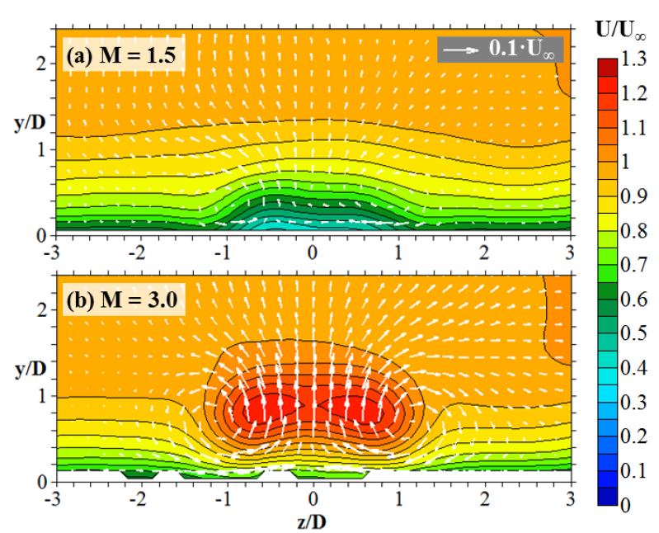
Figure 1.11: Contours of mean stream-wise velocity at x/d = 4 overlaid with the mean secondary flow vectors. These profiles were measured by PIV by Schroeder and Thole [45]
1.3.3 Effect of Internal Coolant Feed
The majority of previous film cooling studies in the literature have made use of a quiescent plenum to feed the cooling holes, which is an unrealistic configuration. In a typical film-cooled gas turbine rotor blade, coolant enters the blade through its base and flows through a series of passages, as shown in Figure 1.2. In these passages, it is common for internal coolant to be flowing perpendicular to the direction of the mainstream flow, or in an internal crossflow. In stator vanes, coolant often impinges on the internal surface of the leading edge and then flows around the walls of the vane to feed the downstream rows of film cooling holes. In that case, holes would be fed by an internal coflow, parallel to the mainstream flow direction, whereas internal counterflow, tested in some studies, is directed in the opposite direction as the mainstream flow. In the discussion of the literature, there will also be a distinction made between holes fed by an internal flow that feeds the holes and continues on and a terminating internal flow where all of the coolant is fed into the holes. Given that the latter is less common, it will be noted when it occurs, otherwise the internal flow can be assumed to continue past the rows of holes, as is typical in turbine rotor blades. Regardless of the coolant feed orientation, numerous studies have shown that there is an effect of changing the configuration, direction, and magnitude of the internal feed on external film cooling performance, which is an important consideration in gas turbine film cooling design.
The first study to examine the effect of internal coolant feed orientation on film cooling was Hay et al [46] which studied the effect of internal coflow and counterflow on the discharge coefficient of normal and inclined cylindrical film cooling holes. It was shown that for inclined film cooling holes that increasing the coflow Mach number increased the discharge coefficient, while increasing the crossflow Mach number tended to reduce the discharge coefficient. These results suggest that coflow reduced the difficulty for the coolant to enter the hole as it already has a stream wise velocity component, while crossflow forced the coolant to make a more difficult turn into the hole, thus reducing the discharge coefficient. Bunker and Bailey [47] performed a similar study for cylindrical holes fed by crossflow, coflow, and counterflow while introducing rib turbulators to the coolant channel. It was shown that for all flow directions, introducing the rib turbulators had a significant effect. Given the variations in pressure through the channel induced by the flow over the ribs, the location of the rib was also shown to be important to the discharge coefficient. Studies by Gritsch et al [48, 49] investigated the effect of crossflow on round and shaped film cooling holes respectively. The study of shaped holes showed that increasing the internal coflow Mach number had the effect of increasing the discharge coefficient to a value of over unity for low pressure ratios, while similarly to cylindrical holes, increasing the crossflow Mach number reduced the discharge coefficient.
A number of studies have found that the changing internal coolant flow feed affects the external film cooling effectiveness and heat transfer for cylindrical holes. Hale et al [50] measured film cooling effectiveness from normal and inclined cylindrical holes of varying hole length fed by a terminating coflow and counterflow. There were significant effects to varying injection angle, hole length, and internal flow direction with no consistent trend for varying any of the parameters. A second study by Hale et al [51] focused on normal injection and found that the counterflow fed jets had increased heat transfer coefficient augmentation due to the higher levels of turbulence generated because the coolant navigated a 180° turn. Flow field measurements and surface streak visualizations suggest, however that the jets fed by counterflow reduced jet liftoff due to a weakening of the CRVP relative to the coflow fed jets. Gritsch et al [52] observed that internal crossflow caused a skewed adiabatic effectiveness profile for flow from cylindrical holes and increased lateral spreading of coolant. This effect was investigated further in another study by Gritsch et al [53]. Interestingly, the coolant jets were skewed toward the windward side of the hole relative to the internal crossflow direction. Two possible explanations for this result is that either there was some reflection of the coolant jet within the hole, or that the low momentum coolant on the windward side of the hole stayed particularly well attached after exiting the hole. The improvement in adiabatic effectiveness of round holes due to crossflow was most notable at higher blowing ratios where the crossflow effects counteracted the tendency of the cylindrical jets to detach from the surface. Another study by Saumweber et al [54] observed the same effects for crossflow and also found that a coflow feeding coolant holes had the effect of improving film effectiveness by elongating the region of high effectiveness going downstream. Kissel et al [55] tested the effect of introducing internal ribs to crossflow fed cylindrical cooling holes. It was found that for low Re_{d}, introducing ribs caused an increase in adiabatic effectiveness while the reverse was true for higher Re_{d}. McClintic et al [56] and Klavetter et al [57] examined the effect of crossflow on compound angle cylindrical holes and found considerable sensitivity to crossflow direction of adiabatic effectiveness for holes fed by a smooth channel. This sensitivity, as well as the magnitude of the adiabatic effectiveness, was diminished somewhat by introducing rib turbulators to the internal channel.
The effect of internal flow feed on the adiabatic effectiveness of shaped holes has been found to be considerably more interesting than that for cylindrical holes. Gritsch et al [52] was the first study to measure adiabatic effectiveness for shaped film cooling holes fed by an internal coflow and crossflow. It was observed that crossflow caused the jet to bias towards one side of the diffuser, reducing adiabatic effectiveness considerably. Jet biasing due to internal crossflow effects for laidback fan-shaped film cooling holes is shown in Figure 1.12. The data shown is from Gritsch et al [53], which investigated internal crossflow effects further and for more conditions. As crossflow is introduced, the jets bias strongly towards the windward side of the hole relative to the direction of the internal crossflow (the crossflow flows from the bottom to the top of the figure). An exception to the rule is at the greatest internal crossflow Mach number and lowest blowing ratio, where the jet biases towards the leeward side of the hole instead. Similar results were found for fan-shaped holes with no forward diffusion; however, crossflow biased the jet toward the leeward side of the hole instead of the windward side. Saumweber et al [54] measured the effect of internal coflow on fan-shaped film cooling holes and found that it tended to increase adiabatic effectiveness, unlike internal crossflow. These studies emphasize the need to understand how the flow develops both in the entrance region of a shaped hole as well as within the diffuser in order to better explain these trends in film cooling effectiveness. Another study by Saumweber and Schulz [58] investigated the effect of various geometric parameters for fan-shaped film cooling holes fed by a plenum and crossflow. They found that the introduction of crossflow, when coupled with varying film cooling hole geometric parameters yielded a wide variety of results that made drawing general conclusions difficult. For example, fan-shaped holes with an injection angle of α = 45° suffered a much more severe degradation in film cooling effectiveness due to crossflow than holes with injection angles of α = 30° and 60°, underscoring the need for a better understanding of the flow physics of crossflow-fed diffused holes.
A number of studies have undertaken to better explain the effects of internal crossflow effects on film cooling holes by studying flow fields in and around the holes. Lloyd and Brown [59] experimentally measured flow fields in a pipe fed by a normal crossflow. It was found that the initial turbulence levels were very high (Tu = 55% which was well outside of the measurement range of the hot-wire anemometer used to make the measurements), and the inlet velocity profile was highly skewed. The high turbulence levels and skewed pipe velocity profile persisted for about four pipe diameters before beginning to subside. During this distance, the region of maximum velocity rotated by about 45°, indicating swirling within the pipe. The metering length for most shaped holes studied in the literature is around L_{T} = 2, or well within the region of high turbulence and non-uniform velocity profiles. At lower pipe-to-channel velocity ratios the inlet turbulence and velocity gradients increased. A series of studies was performed by Peterson and Plesniak [60, 61, 62] examining the flow fields of cylindrical holes fed by either a terminating internal coflow or counterflow. Among the observations made by these studies was that the in-hole vortices were strongly influenced by the inlet flow feed direction. The strength and orientation of these vortices was strongly dependent on flow feed direction and injection flow rate, with counterflow and higher injection flow rates producing stronger in-hole vortices. These vortices were also observed to either contribute to or detract from the strength of the primary CRVP in the downstream jet, which has been shown to contribute to jet lift-off and lower adiabatic effectiveness.
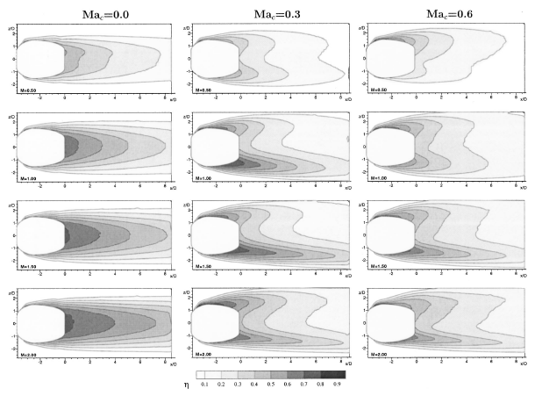
Figure 1.12: Effect of introducing crossflow (increasing Ma_{c}) at varying blowing ratio for laidback fan-shaped film cooling holes. Crossflow is from bottom to top [53]
As mentioned previously, Thole et al [34] measured the flow fields downstream of fan-shaped and laidback fan-shaped holes fed by an internal co-flow. As noted before, this study found that there was little evidence for the existence of a separation region at the entrance to the hole as seen in in previous studies such as Pietrzyk et al [11] in which the holes were fed from a quiescent plenum. Porter et al [63] also experimentally measured flow fields for fan-shaped holes fed by internal co-flow and found that increasing the coflow velocity caused reduced jetting and turbulence of coolant exiting the hole.
A number of computational studies have focused on explaining the effect of internal crossflow and coflow on shaped film cooling holes. Giebert et al [64] simulated coflow-fed cylindrical, fan-shaped and laidback fan-shaped film cooling holes and compared to experimental results for certain configurations. It was shown that turbulence was primarily generated within the diffuser and that the bulk of the coolant for the laidback fan-shaped hole exited out of the downstream portion of the hole. However, the computation was shown to poorly predict the flow physics in the hole: it under-predicted the level of mainstream ingestion into the hole and turbulence intensity in the hole but over-predicted the strength of secondary flows at the diffuser outlet and the size of the downstream CRVP. Kohli and Thole [65] performed perhaps the most comprehensive computational study of the effects of internal flow on shaped film cooling holes. They studied the effects of blowing ratio, internal flow Reynolds number, and metering hole length on the flow field of laidback fan-shaped holes fed by internal crossflow, coflow, and counterflow. They predicted that compared to a plenum-fed baseline condition, coflow generally improved film cooling effectiveness, crossflow reduced effectiveness, and counterflow was not much different than the plenum-fed condition. The computation also found that cross-flow fed holes were much more susceptible to mainstream ingestion that other feed conditions, likely due to biasing of the jets toward the windward side of the hole relative to the crossflow direction. It was also found that increasing the crossflow Reynolds number increased jet biasing and the strength of secondary flow within the hole. Reducing metering length also significantly increased predicted adiabatic effectiveness for crossflow-fed holes. It was shown that the shorter metering length led to increased jetting in the upstream portion of the hole (relative to the mainstream flow direction) that served to block the incoming mainstream flow and reduce ingestion. This result is contrary to what was observed by McGrath and Leylek [37] for compound angle, plenum-fed, forward diffused holes where increased jetting led to increased ingestion. Another study by Adami et al [66] investigated the effects of crossflow on round, fan-shaped, and laidback fan-shaped holes. They observed significant jetting and recirculation within the hole and swirling within the diffuser, especially on the side of the hole towards which the coolant was biased. Saumweber and Schulz [67] performed a performed a similar study of cylindrical and fan-shaped film cooling holes fed by an internal crossflow. They found that crossflow produced an asymmetrical vortex within the hole as opposed to the symmetric in-hole CRVP that formed for plenum-fed holes. This asymmetrical vortex caused the development of an asymmetrical flow field downstream of the holes that resulted in the profiles shown in Figure 1.13. The crossflow-fed jet profile on the right features two co-rotating vortices that served to increase coolant dispersion into the mainstream and brought hot mainstream gas down into the center of the jet. The strength of the vortices for the crossflow-fed jet was also shown to be greater than that of the CRVP featured in the plenum-fed jet on the left. Peng and Jiang [68] performed an experimental and computational study of round, fan-shaped, and trenched film cooling holes and made similar observations to those made by Adami et al [66] and Saumweber and Schulz [67].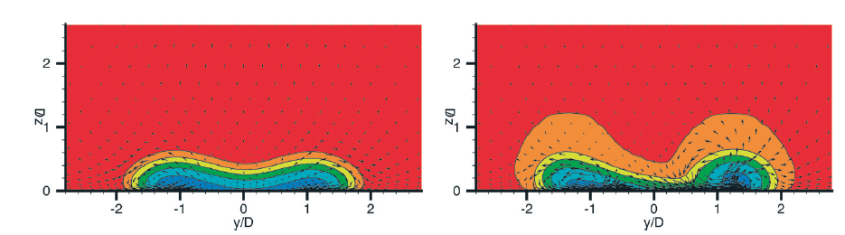
Figure 1.13: Computational predictions of thermal and flow fields downstream of axial fan-shaped holes fed by a plenum (left) and internal crossflow (right) [67]
1.3.4 Relevance of Proposed Study
There are currently no experimental measurements of flow and thermal fields for shaped film cooling holes fed by an internal crossflow. As previous studies have shown, crossflow has a strong effect on the film cooling performance of shaped film cooling holes, but the flow physics governing these effects remains largely unstudied. Given that shaped holes fed by crossflow are a very common engine film cooling configuration, an effort to understand the important flow structures governing their performance could be of great value to engine designers seeking to improve their performance. While a number of computational studies have undertaken to explain these effects, without experimental data, it is impossible to validate these studies and provide a means to making better computational predictions.
Section 2: Experimental Facility
2.1 Current Facility
The majority of proposed experiments for the present study will be conducted in a closed loop recirculating wind tunnel, with a test section set up to run flat plate film cooling experiments, shown in Figure 2.1. The main flow loop is driven by a 22 kW (30 hp) belt-driven fan capable of providing a maximum flow rate of U∞ = 70 m/s (Ma∞ = 0.20) to the inlet of the test section. The temperature of the mainstream flow is measured by two type E thermocouples near the inlet of the test section and is regulated by chilled water provided by a 5-ton chiller (not shown) and can be held steady to within ± 0.5 K of the set temperature. To maintain low humidity within the tunnel, desiccant wells are installed in both the main flow loop and within the secondary coolant loop. Low humidity is required for high density ratio film cooling tests to avoid frost formation in the coolant delivery system. A dew point of T_{dp} < -30°C can be maintained in the test section, which is sufficient to avoid frost formation in most cases. Flow straighteners and a 9:1 contraction nozzle ensure that flow at the inlet to the test section has a low turbulence intensity of Tu = 0.5%.
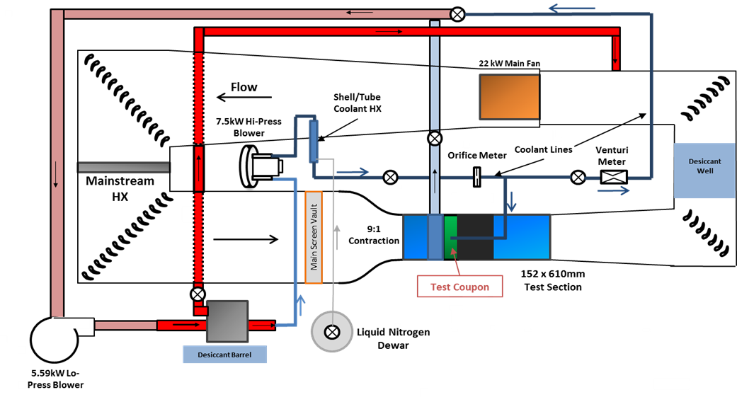
Figure 2.1: Schematic of the recirculating flat plate film cooling experimental facility
The test section, shown in Figure 2.2, has an inlet area of 152 x 610 mm (6” x 24”). A turbulence grid can be installed in one of three stream-wise positions, allowing for the option of running experiments at elevated mainstream turbulence to better simulate the highly turbulent mainstream flow that is typical of gas turbine engine conditions. While the full range of possible turbulence intensities and length scales for the present test section configuration has not been tested, an intensity range of 4-9% should be possible with length scales set by the thickness of the gaps between bars. For recent studies, the mainstream turbulence has been set to Tu∞ = 5.5% with a length scale of Λ_{x} = 10 mm at the hole breakout plane. The approach boundary layer can be removed through use of a suction plenum, connected to the auxiliary flow loop. The proper suction level can be maintained by monitoring the ratio between velocity in the test section measured upstream and downstream of the suction plenum by pitot-static probes. The correct suction setting ensures that the boundary layer on the flat plate starts at the leading edge. The approach boundary layer can be thickened if necessary by installing a trip upstream of the film cooling holes. Approach boundary layer thicknesses just upstream of the hole breakout can be set within a range of δ = 5-20 mm. Figure 2.2 shows a crossflow channel installed in the test section to provide coolant in a direction normal to the overflowing mainstream. A quiescent plenum can also be installed to feed the coolant holes.
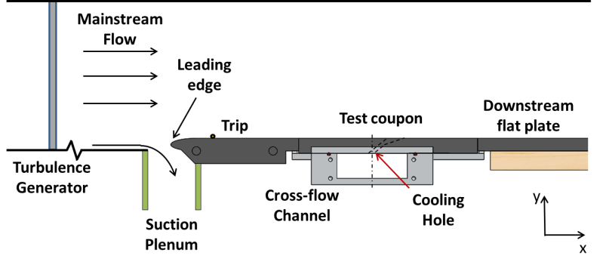
Figure 2.2: Schematic of the flat plate test section
Coolant is provided to the film cooling holes through the secondary coolant loop shown in Figure 2.1. Air is drawn from the main flow loop by a 5.59 kW (7.5 hp) centrifugal blower and dried in the secondary loop desiccant well. Air is drawn from the desiccant well by a 7.5 kW (10 hp) regenerative blower and into the coolant heat exchanger where it exchanges heat with liquid nitrogen (LN2) supplied by a 160 L dewar. The coolant system is configured to use either pure nitrogen gas (brought to a super-heated state in the coolant heat exchanger) or the air from the main flow loop as coolant. Using air is preferable for ease of operation and reduced use of LN2, but for higher density ratio experiments requiring colder coolant, it is advantageous to use pure nitrogen as coolant to avoid frost in the coolant line during the course of long experiments. An orifice flow meter is used to measure the coolant flow rate entering the channel or plenum. For crossflow experiments, some of the coolant is exhausted into the main flow loop as coolant while the rest passes through the channel and back into the main flow loop. The coolant supply to the channel is configured to allow flow in either direction in the channel, which is important for making repeatability checks and studying film cooling with compound angle injection. The flow rate of coolant leaving the channel is measured using a Venturi flow meter which is calibrated against the inlet orifice plate to remove calibration biases in the film cooling flow rate measurement.
The coolant crossflow channel has cross-sectional dimensions of 25 mm x 70 mm and a total length of 1680 mm. Screens are installed at the inlets in order to quicken flow development such that the flow within the channel is fully developed well upstream of the film cooling holes. Thermocouples are installed at both channel inlets for measuring the coolant temperature. The channel is constructed to allow the installation of rib turbulators within the passage to simulate the effects of this common heat transfer-enhancing geometry. For cases requiring plenum-fed holes, a coolant plenum is available. It features several screens to dissipate turbulent structures in the flow and the supply velocity of coolant in the plenum is less than 1% the mainstream velocity.
2.2 Film Cooling Models and Parameters
The film cooling holes will be machined into a rectangular coupon made from closed cell polyurethane foam (General Plastics Last-a-Foam R-3315). The foam is machinable and has a low thermal conductivity of k = 0.044 W/m∙K. The coupon(s) will be bolted and sealed to the crossflow channel or plenum and the assembled channel/plenum will be installed in the test section.
The film cooling geometry to be studied will be the 7-7-7 hole introduced by Schroeder and Thole [32]. This geometry is a narrow-angled, laidback fan-shaped hole. Adiabatic effectiveness measurements of this geometry in the presence of internal crossflow have already been made by Wilkes et al [69] using the same facility. Other studies of this geometry in the current facility include Boyd et al [70], Anderson et al [71], and Anderson et al [72], all of which fed the holes by a quiescent plenum. The peak effectiveness for this geometry occurs at around M = 1.0, although internal flow parameters have been shown to affect that peak blowing ratio somewhat.
The hole diameter is not yet set. It is advantageous to make the hole diameter as large as possible while still maintaining the desired Reynolds number based on hole diameter and mainstream flow properties, which typically ranges from Re_{d} = 5,000-25,000. To maintain a Reynolds number within the desired range, the holes could have a maximum diameter of d = 7.5 mm. If a lower Reynolds number is desired, either the hole diameter or mainstream velocity must be reduced.
The range of experimental parameters is given in Table 2.1 below. The key experimental parameters to vary for this study are channel-to-mainstream velocity ratio, VR_{ch}, and the external Reynolds number, Re_{d}, both of which have been shown to have significant effects on film cooling effectiveness [69, 72].
Table 2.1: Likely Range of Parameters for Flow Field Experiments
Parameter | Value/Range
Hole Diameter, d | 4.0 – 7.5 mm
Density Ratio, DR | 1.5 – 1.8
External Reynolds Number, Re_{d} | 13,000 – 25,000
Channel-to-Mainstream Velocity Ratio, VR_{ch} | 0.3 – 1.0
External Mach Number, Ma∞ | 0.05 – 0.15
Blowing Ratio, M | 0.5 - 3.0
Approach BL Thickness, δ/d | 1.0 – 3.0
Approach Turbulence Level, Tu | 0.5 – 7.0%

2.3 Overview of Measurement Techniques
Approach Velocity and Turbulence Measurements
The approach boundary layer and mainstream turbulence characteristics will be measured with an A.A. Lab Systems AN-1003 hotwire anemometer with a single component hotwire probe. The probe will be calibrated against a pitot-static probe by varying the mainstream velocity.

Adiabatic Effectiveness and Heat Transfer Augmentation
Adiabatic effectiveness and heat transfer augmentation will be measured using a FLIR model A655sc infrared (IR) camera. The camera will provide spatial resolution on the order of 0.5 mm, or about 7% of the film cooling hole diameter. A stream-wise viewing region of about 250 mm (or about 33 hole diameters) is attainable. If effectiveness data is desired for regions further downstream, a second camera can be utilized. Optical access to the test surface is available through a zinc-selenide window. The camera will be calibrated in situ against a type E thermocouple placed on the surface. Previous IR calibrations in this lab have had an accuracy of around ±1 K which equates to 0.007 in η for a density ratio of DR = 1.8.
Three experiments will need to be conducted to measure both heat transfer augmentation and adiabatic effectiveness. The first experiment will measure the surface temperature of the plate in the presence of film cooling to measure T_{s1}. The second experiment will measure the surface temperature of the plate with film cooling and a thin foil (t ≈ 0.05 mm) heat flux plate installed on both the film cooling surface and upstream of the holes to respectively deliver a near-constant heat flux to the film-cooled surface and create a thermal boundary layer upstream of the holes. The local heat flux can be corrected based on the temperature of the foil to account for the changing electrical conductivity of the foil with varying temperature. The second experiment will provide measurements of T_{s2} and q₂”. The third experiment will be conducted with the heat flux plate turned on, but no film cooling to measure T_{s3} and q₃”.
Experiments will be run at steady state conditions. For each blowing condition, multiple IR images will be taken over a span of 5-10 minutes after steady state coolant conditions are reached to ensure that steady state conditions have been reached. The backside temperature of the test plate will also be monitored by a series of thermocouples in order to ensure that there is minimal transient conduction within the plate. Previous experiments have found that steady state is usually reached within a couple minutes of establishing a steady coolant feed condition.
A conduction correction will be implemented for the three cases under consideration using the finite element heat transfer solver in the Comsol Multiphysics® computational suite. The inputs to the solver will be the measured surface and backside temperatures as well as a predicted channel heat transfer coefficient (previous models have shown that the conduction correction is relatively insensitive to the channel heat transfer coefficient). For experiment 1, the solver will output a heat flux distribution for the top surface. For experiments 2 and 3, the solver will also solve for the conductive heat flux at the top surface which can be subtracted from the measured heat fluxes. After implementing a radiation correction, the corrected/predicted heat fluxes and measured temperatures for experiments 1 and two can be used to solve for both the adiabatic wall temperature, T_{aw}, and the heat transfer coefficient with film cooling present, h_{f}, using Equations 2.1 and 2.2. The heat transfer coefficient without film cooling can be computed simply using Equation 2.3.
$$q_{1}"=h_{f}(T_{aw}-T_{s1})$$ | (2.1)
$$q_{2}"=h_{f}(T_{aw}-T_{s2})$$ | (2.2)
$$q_{3}"=h_{0}(T_{∞}-T_{s1})$$ | (2.3)

Note that for most configurations, time restrictions do not allow for heat transfer augmentation to be measured along with adiabatic effectiveness. When only adiabatic effectiveness is desired, the process can be simplified by assuming h₀ = h_{f}. This necessarily introduces errors into the measured adiabatic effectiveness on the order of 0.01 in η.
Velocity Field Measurements
Particle image velocimetry (PIV) will be used to measure flow fields in the mainstream downstream of the hole and within the cooling channel. The test section is made of clear acrylic and should provide excellent optical access for the camera and laser sheet used to measure velocity fields in the main flow loop. Optical access will have to be provided for the channel, which is constructed from aluminum. Ports will have to be installed in the channel to allow for study of the flow within the channel. For external measurements, both the mainstream and the coolant flow will need to be seeded such that neither flow is biased relative to the other. Care will be taken in selecting a seeding particle that is the proper size and performs well at low coolant temperatures. The quality of PIV data measured in this study is expected to be similar to that shown in Figure 1.11 [45].
Laser Doppler velocimetry will be used to make measurements closer to the film cooling hole and in the hole exit plane, and anywhere else where it is difficult to make PIV measurements. The flow will be seeded similarly to PIV measurements.
A flow visualization method will be developed to study the flow within the diffuser of the hole. Developing this method will present a number of challenges, especially determining how to seed the flow to observe the flow structures of interest.
Thermal Field Measurements
Thermal field measurements will be made with a microthermocouple probe. The probe will be used to measure thermal fields in the near-hole region and in the diffuser itself and will enter the tunnel through the top of the test section. The probe is constructed using 0.05 mm diameter type E thermocouple wire secured to a repurposed hot film probe holder with a prong diameter of 0.3 mm. The prongs are insulated to prevent electrical conductivity between the wire and the metal prongs. The probe will be calibrated using a series of constant temperature baths at known temperatures, down to the boiling temperature of liquid nitrogen (77.35 K). Previous calibrations of the probe had an accuracy of ±0.2 K.
2.4 Development of a New Facility
A new wind tunnel facility is currently under development to match engine Mach and Reynolds numbers for film cooling experiments. It will feature both a cascade and a flat plate test section connected in parallel to the main blower. Flow in the main loop will be driven by a 450 kW (600 hp) multi-stage centrifugal blower. Flow in the flat plate test section, which is relevant to this current study, will have maximum inlet Mach number of Ma∞ = 0.80, maximum inlet temperature of T_{0,∞} = 450 K, and will be able to provide air at gauge pressures between -0.75 atm and 1 atm in order to match the desired Reynolds number. This facility is expected to be available in the spring of 2017.

Section 3: Dissertation Objectives

The objective of this study is to further the understanding of how internal crossflow affects the performance of axial film cooling holes with diffused exits. This goal will be achieved by making surface and flow field measurements that track the development of the film cooling jet from the inlet of the hole to the jet-mainstream interaction in the near-hole region. This data would fill an important gap in the literature, providing both important insights to engine designers and data for validation of computational codes.
3.1 Investigate a wide range of internal and external flow parameters
Previous studies have shown that there is an effect of internal crossflow velocity [53, 69] and external Reynolds number [72] on the film cooling effectiveness of axial shaped film cooling holes. However, the amount of available data in the literature is small and covers a small range of parameters. Film cooling effectiveness, discharge coefficients, and heat transfer augmentation will be measured for a range of internal crossflow-to-mainstream velocity ratios and external Reynolds numbers (the ranges are given in Table 2.1). These measurements will provide further insight into the effect of internal and external parameters on film cooling performance and will allow for the identification of conditions of interest for flow and thermal field measurements.
3.2 Determine how crossflow affects flow development within the diffuser
Previous experimental measurements of film cooling effectiveness for laidback fan-shaped holes fed by internal crossflow have observed a biasing of peak effectiveness toward the windward side (relative to the crossflow direction) of the diffuser [53, 69]. It is expected that a separation region forms on the windward side of the cooling hole inlet based on previous experimental studies [59]. It is further expected that most of the coolant accelerates around this separation region on the leeward side of the hole. It is therefore surprising to see that the peak effectiveness is biased toward the windward side of the hole. No experimental flow field studies have attempted to explain this phenomenon.
To study the internal crossflow effect on the development of flow within the diffuser, a flow visualization method will be implemented. It is hoped that the flow visualization study will reveal the important flow features that govern how the flow develops in the diffuser as a result of separation at the inlet of the hole. This observation is essential to understanding how crossflow affects film cooling performance.
3.3 Provide new insight on ingestion into shaped film cooling holes
A number of computational studies [36, 37, 65] have predicted ingestion into laidback fan-shaped film cooling holes fed both by a plenum and internal crossflow. Thole et al [34] made flow field measurements indicating ingestion along the centerline of laidback fan shaped holes fed by an internal coflow. Given the demonstrated unreliability of computational methods applied to film cooling thus far and the limited experimental data regarding ingestion into shaped film cooling holes, there is much that is not understood about the physical mechanisms causing ingestion and the extent of ingestion into the diffuser.
Flow field measurements will be made at the exit plane of the diffuser to investigate ingestion into the hole. Two component LDV will be used to measure the x and y-components of velocity in the exit plane. These measurements will identify locations of negative y-velocity (into the diffuser) corresponding to ingestion into the hole. Knowing the locations of ingress into the hole, in combination with flow visualization observations, will help to determine the physical mechanisms causing ingestion, which has never been experimentally studied.
Thermal fields within the diffuser will also be measured using a microthermocouple probe. While velocity field measurements can help explain the mechanisms for ingestion, thermal fields are necessary to determine the extent of its effects on film cooling performance. These measurements will be the first of their kind in the open literature.
3.5 Examine how internal crossflow affects vortical flow within the downstream jet
A number of previous studies have hypothesized that vortical structures within the film cooling hole affect the development of the counter-rotating vortex pair that is characteristic of symmetric film cooling holes [29, 33]. A computational study by Saumweber and Schulz [67] predicted that internal crossflow feeding a fan-shaped hole resulted in the asymmetrical co-rotating vortical pattern shown in Figure 1.13. There are no experimental measurements of the secondary flows downstream of shaped film cooling holes fed by an internal crossflow or thermal field measurements showing how the vortical motion affects the spread of coolant.
Velocity fields will be measured using PIV in y-z cut-planes over and downstream of the film cooling holes in order to study vortical flows in the film cooling jets. These measurements will be similar in nature to those shown in Figure 1.11. Accompanying thermal fields will also be measured to show how the coolant is transported by vortical motion.
An additional item of interest is measuring velocity and thermal fields in x-y cut-planes at selected span-wise locations in order to observe how shear layers and mainstream turbulence contribute to the transport of coolant away from the wall. It has been observed that shear layers are much weaker for shaped holes than for round holes [34] but it is possible that jets from holes fed by internal cross-flow could be affected by stronger shear layers and increased turbulent mixing.
3.6 Show how internal crossflow velocity ratio affects how coolant enters the hole
The separation region at the inlet of a film cooling hole is affected by the turning of coolant entering the hole – the more extreme the angle that must be navigated by the entering coolant, the larger the separation region. Very few studies have examined how coolant turns into film cooling holes [59, 61] due to internal flows. While it is clear that increasing the internal crossflow velocity would increase the difficulty of coolant entering the hole, it is not clear how the internal crossflow velocity and the injection rate interact to affect how coolant enters the hole. Understanding the entrance effects could provide insight to external flow field measurements.
Internal channel velocity fields will be measured using PIV in a y-z plane under the midline of the hole inlet for varying internal flow and injection rates. While this method will be unable to measure the separation region at the hole inlet, it will capture how the internal flow turns to enter the hole, which will provide insight as to how the flow develops through the hole, especially when paired with flow visualization and external flow field measurements.
3.7 Use of the New Facility
As mentioned previously, a new facility designed to run at matched Mach and Reynolds numbers expected to be available for testing in the spring of 2017. The current plan does not include the use of this facility, but it would be possible to measure adiabatic effectiveness for the selected configuration to gauge the effect of running at engine-scale Mach numbers on crossflow-fed cooling holes. As the construction of the new facility goes forward and the operational date becomes more certain, including experiments run in the new facility in the current study may become more or less feasible.
3.8 Collaboration with Computational Studies
The experimental work proposed above will provide important data for the evaluation of computational simulations being developed to predict film cooling performance. Currently our laboratory is partnered with a computational group at the University of Texas that is currently performing a direct numerical simulation of a plenum-fed 7-7-7 film cooling hole. While there are currently no plans for a computational effort to investigate the effects of crossflow, this data will still be valuable to any future computational studies of that nature, especially for validating simulations of flow through the film cooling hole.

Section 4: Schedule
Task | Estimated Completion
Design and construction of test coupons | March 2016
Adiabatic effectiveness experiments | May 2016
Heat transfer augmentation experiments | July 2016
Flow visualization experiments | September 2016
Thermal field experiments | October 2016
External PIV experiments | December 2016
External LDV experiments | January 2016
Internal PIV experiments | March 2016
Graduation | May 2016

Section 5: Nomenclature
ENGLISH |  |  | GREEK
Bi | Biot number |  | α | injection angle
d | hole diameter |  | β | lateral expansion angle
d_{H} | hydraulic diameter |  | γ | compound injection angle
DR | density ratio |  | δ | forward expansion angle
h | heat transfer coefficient |  |  | boundary layer thickness
HTA | heat transfer augmentation |  | η | adiabatic effectiveness
I | momentum flux ratio |  | η_{th} | thermal efficiency
k | thermal conductivity |  | θ | normalized gas temperature
L | hole length |  | Λ_{x} | integral length scale
L_{T} | hole metering length |  | μ | dynamic viscosity
M | blowing ratio |  | ρ | density
Ma | Mach number |  | φ | overall effectiveness
P | pressure |  | χ | coolant warming factor
p | hole pitch
$$\dot{Q}$$ | heat rate |  | SUBSCRIPTS
q” | heat flux |  | aw | adiabatic wall
Re | Reynolds number |  | c | coolant
T | temperature |  | ch | internal channel
Tu | turbulence intensity |  | d | hole diameter
U | stream-wise velocity |  | dp | dew point
VR | velocity ratio |  | e | cooling hole exit
x | stream-wise coordinate |  | f | with film cooling
y | wall-normal coordinate |  | m | metal temperature
z | span-wise coordinate |  | s | measured surface temperature
 |  |  | 0 | without film cooling
 |  |  | ∞ | mainstream

Section 6: References
[1] Annual Energy Review 2014; U.S. Energy Information Administration, August 2015, DOE/EIA-0384(2016).
[2] “Brayton Cycle: The Ideal Cycle for Gas-Turbine Engines,” from http://www.yildiz.edu.tr/~dagdas/Brayton%20cycle.pdf
[3] Langston L. S., “Gas Turbine Industry Overview for 2010,” IGTI, Storss, CT, 2010.
[4] Han J. C, Dutta, S., and Ekkad, S. V, 2000, Gas Turbine Heat Transfer and Cooling Technology, 1st ed. New York, USA: Taylor & Francis.
[5] Bogard, D. G. and Thole, K. A., 2006, “Gas Turbine Film Cooling,” J. Propulsion and Power, 22(2), pp. 249-270.
[6] Baldauf, S., Schulz, A., and Wittig, S., 2001, “High-Resolution Measurements of Local Effectiveness from Discrete Hole Film Cooling,” J. Turbomach., 123, pp. 758–765.
[7] Baldauf, S., Schulz, A., and Wittig, S., 2001, “High-Resolution Measurements of Local Heat Transfer from Discrete Hole Film Cooling,” J. Turbomach., 123, pp. 749–757.
[8] Foss, J. F., 1980, “Interaction Region Phenomena for the Jet in a Cross-Flow Problem,” Sonderforschungsbereich 80.
[9] Crabb, D., Durao, D. F. G., and Whitelaw, J. H., 1981, “A Round Jet Normal to a Crossflow,” J. Fluids Eng, 103, pp. 142-153.
[10] Andreopoulos, J. and Rodi, W., 1984, “Experimental Investigation of Jets in a Crossflow,” J. Fluid Mech., 138, pp. 93-127.
[11] Pietzryk, J. R., Bogard, D. G., and Crawford, M. E., 1989, “Hydrodynamic Measurements of Jets in Crossflow for Gas Turbine Applications,” J. Turbomach., 111, pp. 139-145.
[12] Pietzryk, J. R., Bogard, D. G., and Crawford, M. E., 1989, “Effects of Density Ratios on the Hydrodynamics of Film Cooling,” ASME Paper No. 89-GT-175.
[13] Leylek, J. H., and Zerkle, R. D., 1994, “Discrete-Jet Film Cooling: A Comparison of Computational Results with Experimnents,” J. Turbomach., 116, pp. 358-368.
[14] Cho, H. H. and Goldstein, R. J., 1995, “Heat (Mass) Transfer and Film Cooling Effectiveness with Injection through Discrete Holes: Part 1- Within Holes and on the Back Surface,” J. Turbomach., 117, pp. 440-450.
[15] Thole, K. A., Sinha, A. K., Bogard, D. G., and Crawford, M. E., 1992, “Mean Temperature Measurements of Jets with a Crossflow for Gas Turbine Film Cooling Application,” Rotating Machinery Transport Phenomena, J. H. Kim and W. J. Yang, eds., Hemisphere Pub. Corp., New York.
[16] Kohli, A. and Bogard, D. G., 1995, “Adiabatic Effectiveness, Thermal Fields, and Velocity Fields for Film Cooling with Large Angle Injection,” ASME Paper No. 95-GT-219.
[17] Kohli, A. and Bogard, D. G., 1998, “Fluctuating Thermal Field in a Near-Hole Region for Film Cooling Flows,” J. Turbomach., 120, pp. 86-91.
[18] Kohli, A. and Bogard, D. G., 1998, “Effects of Very High Free-Stream Turbulence on the Jet-Mainstream Interaction in a Film Cooling Flow,” J. Turbomach., 120, pp. 785-790.
[19] Kohli, A. and Bogard, D. G., 1998, “Turbulent Transport in Film Cooling Flows,” J. Heat Transfer, 127, pp. 513-520.
[20] Lee, S. W., Lee, J. S., and Ro, S. T., 1994, “Experimental Study on the Flow Characteristics of Streamwise Inclined Jets in Crossflow on Flat Plate,” J. Turbomach., 116, pp. 97-105.
[21] Lee, S. W., Kim, Y. B, and Lee, J. S., 1997, “Flow Characteristics and Aerodynamic Losses of Film-Cooling Jets with Compound Angle Orientations,” J. Turbomach., 119, pp. 310-319.
[22] Lee, S. W., Park, S. W., and Lee, J. S., 2001, “Flow Characteristics Inside Circular Injection Holes Normally Oriented to a Crossflow: Part I – Flow Visualizations and Flow Data in the Symmetry Plane,” J. Turbomach., 123, pp. 266-273.
[23] Kelso, R. M., Lim, T. T., and Perry, A. E., 1996, “An Experimental Study of Round Jets in Cross-flow,” J. Fluid Mech., 306, pp. 111-114.
[24] Morton, B. R. and Ibbetson, A., 1996, “Jets Deflected in a Crossflow,” Experimental Thermal and Fluid Science, 12, pp. 112-133.
[25] Bernsdorf, S., Rose, M. G., and Abari, R. S., 2006, “Modeling of Film Cooling – Part I: Experimental Study of Flow Structure,” J. Turbomach, 128, pp. 141-149.
[26] Jessen, W., Schröder, W., and Klaas, M., 2007, “Evolution of Jets Effusing from Inclined Holes into Crossflow,” Int. J. Heat Fluid Flow, 28, pp. 1312-1326.
[27] Wright, L. M., McClain, S. T., and Clemonson, M. D., 2011, “Effect of Freestream Turbulence Intensity on Film Cooling Jet Structure and Surface Effectiveness Using PIV and PSP,” J. Turbomach., 133, p. 041023.
[28] Eberly, M. K., and Thole, K. A., 2014, “Time-Resolved Film-Cooling Flows at High and Low Density Ratios,” J. Turbomach., 136, p. 061003.
[29] Issakhanian, E., Elkins, C. J., and Eaton, J. K., 2012, “In-Hole and Mainflow Velocity Measurements of Low-Momentum Jets in Crossflow Emanating from Short Holes,” J. Exp. Fluids, 53, pp. 1765-1778.
[30] Goldstein, R. J., Eckert, E. R. G., and Burggraf, F., 1974, “Effects of Hole Geometry and Density on Three-Dimensional Film Cooling,” Int. J. Heat Mass Transfer, 17, pp. 595-607.
[31] Bunker, R. S., 2005, “A Review of Shaped Hole Turbine Film-Cooling Technology,” J. Heat Transfer, 127, pp. 441-453.
[32] Schroeder, R. P. and Thole, K. A., 2014, “Adiabatic Effectiveness Measurements for a Baseline Shaped Film Cooling Hole,” ASME Paper No. GT2014-25992.
[33] Haven, B. A., Yamagata, D. K., Kurosaka, M., Yamawaki, S., and Maya, T., 1997, “Anti-Kidney Pair of Vortices in Shaped Holes and their Influence on Film Cooling Effectiveness,” ASME Paper No. 97-GT-45.
[34] Thole, K. A., Gritsch, M., Schulz, A., and Wittig, S., 1998, “Flowfield Measurements for Film-Cooling Holes with Expanded Exits,” J. Turbomach., 120, pp. 327-336.
[35] Hyams, D. G. and Leylek, J. H., 1997, “A Detailed Analysis of Film Cooling Physics Part III: Streamwise Injection with Shaped Holes,” ASME Paper No. 97-GT-271.
[36] Brittingham, R. A. and Leylek, J. H., 1997, “A Detailed Analysis of Film Cooling Physics Part IV: Compound-Angle Injection with Shaped Holes,” ASME Paper No. 97-GT-272.
[37] McGrath, E. L. and Leylek, J. H., 1999, “Physics of Hot Crossflow Ingestion in Film Cooling,” J. Turbomach., 121, pp. 532-541.
[38] Kohli, A. and Bogard, D. G., 1999, “Effect of Hole Shape on Film Cooling with Large Angle Injection,” ASME Paper No. 99-GT-165.
[39] Berger, P. A. and Liburdy, J. A., 1998, “A Near-Field Investigation into the Effects of Geometry and Compound Angle on the Flowfield of a Row of Film Cooling Holes,” ASME Paper No. 98-GT-279.
[40] Hildebrandt, T., Ganzert, W., and Fottner, L., 2000, “Systematic Experimental and Numerical Investigations on the Aerothermodynamics of a Film Cooled Turbine Cascade with Variation of the Cooling Hole Shape,” ASME Paper No. 2000-GT-298.
[41] Ferguson, J. D., Leylek, J. H., and Buck, F. A., 2002, “Film Cooling on a Modern HP Turbine Blade Part III: Axial Shaped Holes,” ASME Paper No. GT-2002-30522.
[42] McGrath, E. L., Leylek, J. H., and Buck, F. A., 2002, Film Cooling on a Modern HP Turbine Blade Part III: Compound-Angle Shaped Holes,” ASME Paper No. GT-2002-30521.
[43] auf dem Kampe, T., Völker, S., Sämel, T., Heneka, C., Ladisch, H., Schulz, A., and Bauer, H. J., 2013, “Experimental and Numerical Investigation of Flow Field and Downstream Surface Temperatures of Cylindrical and Diffuser Shaped Film Cooling Holes,” J. Turbomach., 135, p. 011026.
[44] Issakhanian, E., Elkins, C. J., and Eaton, J. K., 2016, “Film Cooling Effectiveness Improvements Using a Nondiffusing Oval Hole,” J. Turbomach., 138, p. 041004.
[45] Schroeder, R. P. and Thole, K. A., 2015, “Effect of High Freestream Turbulence on Flowfields of Shaped Film Cooling Holes,” ASME Paper No. GT2015-43339.
[46] Hay, N., Lampard, D., and Benmansour, S., 1983, “Effect of Crossflows on the Discharge Coefficient of Film Cooling Holes,” J. Eng. Power, 105, pp. 243-248.
[47] Bunker, R. S. and Bailey, J. C., 2000, “Film Cooling Discharge Coefficient Measurements in a Turbulated Passage with Internal Cross Flow,” ASME Paper No. 2000-GT-0135.
[48] Gritsch, M., Schulz, A., and Wittig, S., 2001, “Effect of Crossflows on the Discharge Coefficient of Film Cooling Holes with Varying Angles of Inclination and Orientation,” J. Turbomach., 123, pp. 781-787.
[49] Gritsch, M., Saumweber, C., Schulz, A., Wittig, S., and Sharp, E., 2000, “Effect of Internal Coolant Crossflow Orientation on the Discharge Coefficient of Shaped Film-Cooling Holes,” J. Turbomach., 122, pp. 146-152.
[50] Hale, C. A., Plesniak, M. W., and Ramadhyani, S., 2000, “Film Cooling Effectiveness for Short Film Cooling Holes Fed by a Narrow Plenum,” J. Turbomach., 122, pp. 553-557.
[51] Hale, C. A., Plesniak, M. W., and Ramadhyani, S., 2000, “Structural Features and Surface Heat Transfer Associated with a Row of Short-Hole Jets in a Crossflow,” Int. J. Heat Fluid Flow, 21, pp. 542-553.
[52] Gritsch, M., Schulz, A., and Wittig, S., 1998, “Adiabatic Wall Effectiveness Measurements of Film-Cooling Holes with Expanded Exits,” J. Turbomach., 120, pp. 549-556.
[53] Gritsch, M., Schulz, A., and Wittig, S., 2003, “Effect of Internal Coolant Crossflow on the Effectiveness of Shaped Film-Cooling Holes,” J. Turbomach., 125, pp. 547-554.
[54] Saumweber, C., Schulz, A., Wittig, S., and Gritsch, M., 2001, “Effects of Entrance Crossflow Directions to Film Cooling,” Annals of the New York Academy of Sciences, 934, pp. 401-408.
[55] Kissel, H. P., Weigand, B., von Wolfersdorf, J., Neumann, S. O., and Ungewickell, A., 2007, “An Experimental and Numerical Investigation of the Effect of Cooling Channel Crossflow on Film Cooling Peformance,” ASME Paper No. GT2001-27102.
[56] McClintic, J. W., Klavetter, S. R., Winka, J. R., Anderson, J. B., Bogard, D. G., Dees, J. E., Laskowski, G. M., and Briggs, R., 2015, “The Effect of Internal Crossflow on the Adiabatic Effectiveness of Compound Angle Film Cooling Holes,” J. Turbomach., 137, p.071006.
[57] Klavetter, S. R., McClintic, J. W., Bogard, D. G., Dees, J. E., Laskowski, G. M., and Briggs, R., 2015, “The Effect of Rib Turbulators on Film Cooling Effectiveness of Round Compound Angle Holes Fed by an Internal Cross-Flow,” ASME Paper No. GT2015-43947.
[58] Saumweber, C. and Schulz, A., 2012, “Effect of Geometry Variations on the Cooling Performance of Fan-Shaped Cooling Holes,” J. Turbomach., 134, p.061008.
[59] Lloyd, S. and Brown, A., 1986, “Velocity and Turbulence Fields in Pipe Entrance Regions in the Presence of Cross Flows,” J. Eng. Gas Turbines and Power, 108, pp. 498-503.
[60] Peterson, S. D. and Plesniak, M. W., 2002, “Short-Hole Jet-in-Crossflow Velocity Field and its Relationship to Film-Cooling Performance,” J. Exp. Fluids, 33, pp. 889-898.
[61] Peterson, S. D. and Plesniak, M. W., 2004, “Evolution of Jets Emanating from Short Holes into Crossflow,” J. Fluid Mech., 503, pp. 57-91.
[62] Peterson, S. D. and Plesniak, M. W., 2007, “Flow Structure and Skin Friction in the Vicinity of a Streamwise-Angled Injection Hole Fed by a Short Pipe,” J. Exp. Fluids, 43, pp. 627-638.
[63] Porter, J. S., Henderson, A. D., and Walker, G. J., 2009, “Influence of Inlet Velocity Ratio on the Outlet Flow Uniformity of a Fan-Shaped Film Cooling Hole,” ASME Paper No. GT2009-59581.
[64] Giebert, D., Gritsch, M., Schulz, A., and Wittig, S., 1997, “Film-Cooling from Holes with Expanded Exits: A Comparison of Computational Results with Experiments,” ASME Paper No. 97-GT-163.
[65] Kohli, A. and Thole, K. A., 1998, “Entrance Effects of Diffused Film-Cooling Holes,” ASME Paper No. 98-GT-402.
[66] Adami, P., Martelli, F., Montomoli, F., and Saumweber, C., 2002, “Numerical Investigation of Internal Crossflow Film Cooling,” ASME Paper No. GT-2002-30171.
[67] Saumweber, C. and Schulz, A., 2008, “Comparison of the Cooling Performance of Cylindrical and Fan-Shaped Cooling Holes with Special Emphasis on the Effect of Internal Coolant Cross-Flow,” ASME Paper No. GT2008-51036.
[68] Peng, W. and Jiang, P. X., 2012, “Experimental and Numerical Study of Film Cooling with Internal Coolant Cross-Flow Effects,” J. Exp. Heat Transfer, 25, pp. 282-300.
[69] Wilkes, E. K., Anderson, J. B., McClintic, J. W., and Bogard, D. G., 2016, “An Investigation of Turbine Film Cooling Effectiveness with Shaped Holes and Internal Cross-Flow with Varying Operational Parameters,” ASME Paper No. GT2016-56162.
[70] Boyd, E. J., McClintic, J. W., Chavez, K. F., and Bogard, D. G., 2014, “Direct Measurement of Heat Transfer Coefficient Augmentation at Multiple Density Ratios,” ASME Paper No. GT2014-27085.
[71] Anderson, J. B., Boyd, E. J., and Bogard, D. G., 2015, “Experimental Investigation of Coolant-to-Mainstream Scaling Parameters with Cylindrical and Shaped Film Cooling Holes.” ASME Paper No. GT2015-43072.
[72] Anderson, J. B., Wilkes, E. K., McClintic, J. W., and Bogard, D. G., “Effects of Freestream Mach Number, Reynolds Number, and Boundary Layer Thickness on Film Cooling Effectiveness of Shaped Holes,” ASME Paper No. GT2016-56152.

